FACULTY PROFILE

Name |  |  |  |  | ANILKUMAR V.M |  |  |  |  |  |  |  |  |  |  |  |  |  |  |  |  |  |  | 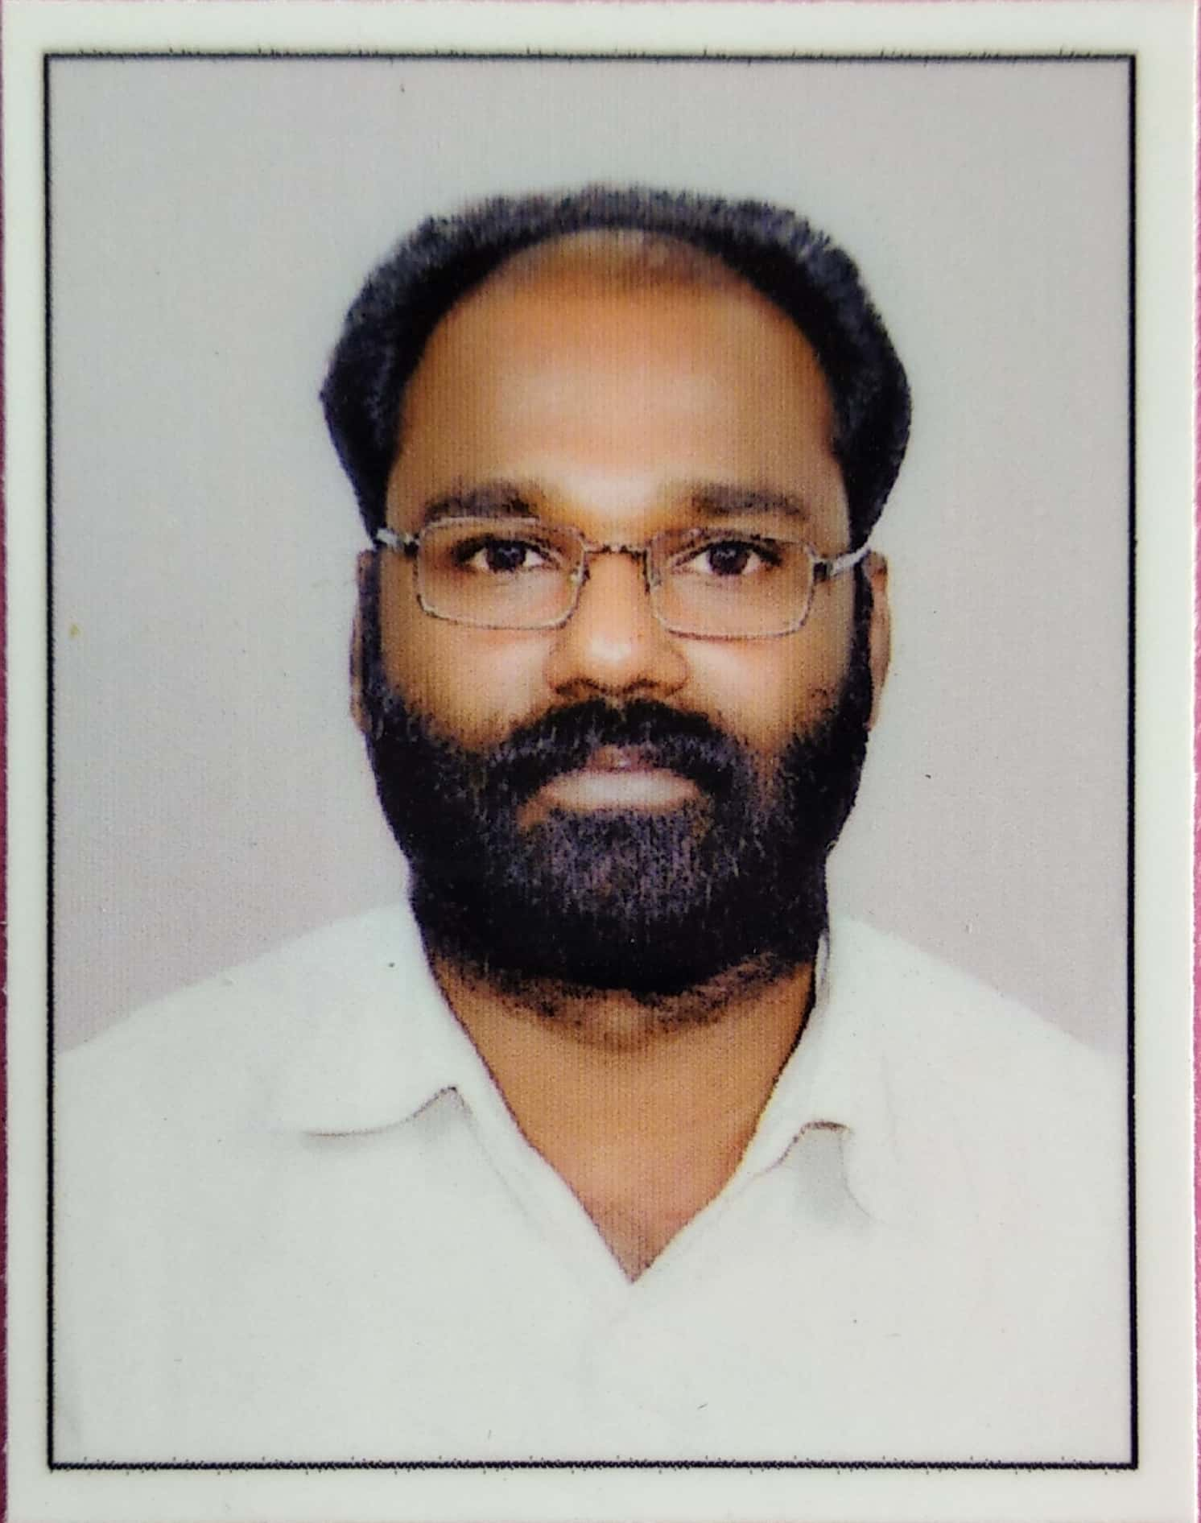
PEN |  |  |  |  | 600590
Designation |  |  |  |  | Assistant Professor
Department |  |  |  |  | Electrical & Electronics Engineering
Institution |  |  |  |  | Government Engineering College, Idukki
Office Address |  |  |  |  | Painavu, Idukki District, Kerala - 685603
Residential Address |  |  |  |  | Quarters No: QA2 ,Staff Quarters  Government Engineering College Idukki ,  Painavu P .O Idukki – 685603.
Phone (Office) |  |  |  |  | 04862- 233250
Resi. |  |  |  |  | 94970 333383
Mobile |  |  |  |  | 9447168426
Email |  |  |  |  | anilkumarvm@gecidukki.ac.in
SUMMARY OF PERSONAL DATA
Date of Joining in service |  |  |  | 14/06/2007 |  |  |  |  |  |  |  |  |  |  | Date of Joining at GECI |  |  |  |  |  |  |  |  |  | 14/06/2007
Current Designation |  |  |  | Assistant Professor |  |  |  |  |  |  |  |  |  |  | Date of Promotion
Total years of Teaching Experience (Govt service) |  |  |  | 15 |  |  |  |  |  |  |  |  |  |  | Other Teaching Experience (years) |  |  |  |  |  |  |  |  |  | NIL
Industrial Experience (years) |  |  |  | 6 |  |  |  |  |  |  |  |  |  |  | Date of promotion to the present post |  |  |  |  |  |  |  |  |  | -
PSC Advice Number |  |  |  | RIC(3)37228/05/GW/1 dtd.20-04-2007
Basic Pay (1/11/2019) : 26930 |  |  |  |  |  |  | AGP : 7000 |  |  |  | HRA : 0 |  |  |  |  |  |  |  | HTA : 500 |  |  |  | GROSS : 84,646
PEN Number |  |  |  | 600590 |  |  |  |  |  |  |  |  |  |  | Gross Salary |  |  |  |  |  |  |  |  |  | 54,500
Gazetted Entitlement Number |  |  |  | A-137/EC |  |  |  |  |  |  |  |  |  |  | Publications with impact factor greater than 1.5* (number) |  |  |  |  |  |  |  |  |  | Nil
PAN Number |  |  |  | AFDPA1428E |  |  |  |  |  |  |  |  |  |  | International Journal Publications (nos) |  |  |  |  |  |  |  |  |  | Nil
Employee ID (DTE) |  |  |  | 3162 |  |  |  |  |  |  |  |  |  |  | Number of International Conference Papers |  |  |  |  |  |  |  |  |  | 1
Aadhar Number |  |  |  | 445236029599 |  |  |  |  |  |  |  |  |  |  | National Conference Publications (nos) |  |  |  |  |  |  |  |  |  | 5
Bank A/C No (optional) |  |  |  |  |  |  |  |  |  |  |  |  |  |  | Blood Group |  |  |  |  |  |  |  |  |  | O+ve
Academic Qualifications
Degree |  |  | Institute |  |  |  |  |  |  |  |  |  | University |  |  |  |  |  |  |  |  |  |  |  |  |  | Year
M.Tech |  |  | Indian Institute of Technology  Delhi |  |  |  |  |  |  |  |  |  | Indian Institute of Technology Delhi |  |  |  |  |  |  |  |  |  |  |  |  |  | 2013
B.Tech |  |  | T K M College of Engineering, Kollam |  |  |  |  |  |  |  |  |  | Kerala ran University of Kerala , |  |  |  |  |  |  |  |  |  |  |  |  |  | 1998
Career History
From - To |  |  |  |  | Name of the Post |  |  |  |  |  |  |  |  | Institution / Industry |  |  |  |  |  |  |  |  |  |  |  | Category
09-11-2000 to 08.05.2002 |  |  |  |  | Executive Trainee ( Electrical ) |  |  |  |  |  |  |  |  | Travancore Cochin Chemicals Ltd Udyogamandal Kochi |  |  |  |  |  |  |  |  |  |  |  | Industry
09-05-2002to 07.05.2006 |  |  |  |  | Senior Engineer ( Electrical ) |  |  |  |  |  |  |  |  | Travancore Cochin Chemicals Ltd Udyogamandal Kochi |  |  |  |  |  |  |  |  |  |  |  | Industry
08-05-2006 to 13-06-2007 |  |  |  |  | Assistant Engineer |  |  |  |  |  |  |  |  | Kerala State Electricity Board |  |  |  |  |  |  |  |  |  |  |  | Industry
14-06-20007 to Till date |  |  |  |  | Assistant Professor |  |  |  |  |  |  |  |  | Govt. Engineering College, Idukki, Painavu |  |  |  |  |  |  |  |  |  |  |  | Teaching
Additional Responsibilites at department/Institute/University level
Sl. No. |  | Duty |  |  |  |  |  |  |  |  |  |  |  |  |  |  |  |  |  | Specify whether department/ institute/university
1 |  | Group Tutor |  |  |  |  |  |  |  |  |  |  |  |  |  |  |  |  |  | Department
2 |  | Lab in Charge |  |  |  |  |  |  |  |  |  |  |  |  |  |  |  |  |  | Department
3 |  | M H wraden |  |  |  |  |  |  |  |  |  |  |  |  |  |  |  |  |  | Imstutute
4 |  | Electrical Maintenance |  |  |  |  |  |  |  |  |  |  |  |  |  |  |  |  |  | Institute
Other Duties Performed at University Level
Areas of Academic Interest
Power Electronics and drives
Renewable Energy
Membership in Academic Bodies
Major Academic Publications
Sl. No. | Name of publication/paper presentation |  |  |  |  |  |  | Details of journals/publications |  |  |  |  |  |  |  |  |  |  |  |  |  |  |  | Date & year paper presentation & Co-Author
1 | “Single phase Five Level Inverter for grid connected Photovoltaic systems ” |  |  |  |  |  |  | Inernational Conference on Advances Tends in Engineering and Technoloogy (ICATET ) at Arya College of Enginnering and IT Kukas Jaipur |  |  |  |  |  |  |  |  |  |  |  |  |  |  |  | 19-20 November 2013, pp.298–302  (Mary George)
2 | “Self-Powered Buck Boost Converter for Low Voltage energy Application ” |  |  |  |  |  |  | Proc.National Conference on Energy Power Electronics and Control , March 26-28 2014 ,GEC Idukki |  |  |  |  |  |  |  |  |  |  |  |  |  |  |  | 26-28 March 2014, pp.12-16  (Alina C R)
3 | “Harmonic reduction using Multi level inveretrs in Grid connected Photovoltaic systems” |  |  |  |  |  |  | Proc.National Conference on Energy Power Electronics and Control , March 26-28 2014 ,GEC Idukki |  |  |  |  |  |  |  |  |  |  |  |  |  |  |  | 26-28 March 2014, pp.74-78  (Mary George )
3 | “ Single phase Stand-Alone Photovoltaic system based on Z- source DC-DC Converter” |  |  |  |  |  |  | Proc.National Conference on Energy Power Electronics and Control , March 26-28 2014 ,GEC Idukki |  |  |  |  |  |  |  |  |  |  |  |  |  |  |  | 26-28 March 2014, pp.79-85  (Meera M K )
Reviewer in National/International Conference
Sl. No. | Details of conference |  |  |  |  |  |  | Institute |  |  |  |  |  |  |  |  |  |  |  |  |  |  |  | Date & year paper reviewed
1 | 2014 IEEE International Conference on Advances in Green Energy |  |  |  |  |  |  | Mar Baselios College of Engineering & Technology, 3hiruvananthapuram and Swinburne University of Technology, Melbourne, Australia |  |  |  |  |  |  |  |  |  |  |  |  |  |  |  | 17-18 December 2014
Attendance in Conferences
Sl. No. | Name of Conference |  |  |  |  |  |  |  |  |  |  |  |  |  |  | Date |  |  |  | Name of institution
1
2
Participation in Faculty Development Programmes/Workshops
Sl. No. | Name of course |  |  |  |  |  |  |  | Period |  |  |  |  |  |  |  | No. of days |  |  |  | Name of institution
Sl. No. |  |  |  |  |  |  |  |  | From |  |  | To
1 | Tools and Techniques for Modelling and Design of Systems |  |  |  |  |  |  |  | 20-02-2008 |  |  | 04-03-2008 |  |  |  |  | 14 |  |  |  | GEC Thrissur
2 | Biomedical Instrumentation |  |  |  |  |  |  |  | 15-03-2010 |  |  | 20-03-2010 |  |  |  |  | 5 |  |  |  | IIT Madras
3 | Embedded Systems and its Application in Power Electronics |  |  |  |  |  |  |  | 05-07-2010 |  |  | 09-07-2010 |  |  |  |  | 5 |  |  |  | IIT Roorkee
4 | Optical Signal Processing |  |  |  |  |  |  |  | 31.01.2011 |  |  | 05.02.2011 |  |  |  |  | 5 |  |  |  | GEC Idukki
5 | Economics and Financing of Renewable Energy Technologies |  |  |  |  |  |  |  | 24.07.2013 |  |  | 27.07.2013 |  |  |  |  | 4 |  |  |  | IIT Deilhi
6 | Electrical System Design using Electrical CAD |  |  |  |  |  |  |  | 31.07.2017 |  |  | 04.08.2013 |  |  |  |  | 5 |  |  |  | GEC Idukki
7 | Microcontroller Based System Design |  |  |  |  |  |  |  | 22.11.2013 |  |  | 26.11.2013 |  |  |  |  | 5 |  |  |  | GEC Idukki
8 | Virtual Instrumentation Using LABVIEW |  |  |  |  |  |  |  | 02.12.2013 |  |  | 06.12.2013 |  |  |  |  | 5 |  |  |  | GEC Idukki
9 | Harmonics and Power Quality Contemporary Issues and Solutions |  |  |  |  |  |  |  | 22.04.2015 |  |  | 05.05.2015 |  |  |  |  | 14 |  |  |  | TCE Madurai
10 | Faculty Development Programme  ( Pedagogy ) |  |  |  |  |  |  |  | 21.09.2015 |  |  | 24.09.2013 |  |  |  |  | 4 |  |  |  | IIT Madras
11 | Challenges on Insulation Reliablity in Smart Grid Application |  |  |  |  |  |  |  | 23.11.2015 |  |  | 27.11.2015 |  |  |  |  | 5 |  |  |  | PEC Pondicherry
12 | Recent Trends in Cryptography |  |  |  |  |  |  |  | 11.11.2015 |  |  | 14 |  |  |  |  | 4 |  |  |  | GEC Idukki
13 | Recent Trends in Control of Drives |  |  |  |  |  |  |  | 18.01.2016 |  |  | 20.01.2016 |  |  |  |  | 3 |  |  |  | GEC Idukki
14 | Outcome Based Education and Accreditaion |  |  |  |  |  |  |  | 04.12.2017 |  |  | 08.12.2017 |  |  |  |  | 5 |  |  |  | GEC Kannur
15 | Emerging Trends in Hybrid Electrical Vehicle Technology |  |  |  |  |  |  |  | 02.12.2019 |  |  | 06.12.2019 |  |  |  |  | 5 |  |  |  | GEC Thrissur
16 | Mind of Builiding –Automation E-Vehicles and Energy conservation |  |  |  |  |  |  |  | 03.09.2020 |  |  | 06.09.2020 |  |  |  |  | 4 |  |  |  | GEC Idukki
17 | Emerging Trends & Potential Energy  Storages in Renewable Systems |  |  |  |  |  |  |  | 03.07.2020 |  |  | 07.07.2020 |  |  |  |  | 5 |  |  |  | MCET Pathanamthitta
18 | Recent Advances in Communication and Networking |  |  |  |  |  |  |  | 28.09.2020 |  |  | 03.10.2020 |  |  |  |  | 5 |  |  |  | GEC Idukki
19 | Emerging Trends & Potential Energy  Storages in Renewable Systems |  |  |  |  |  |  |  | 03.07.2020 |  |  | 07.07.2020 |  |  |  |  | 5 |  |  |  | MCET Pathanamthitta
20 | Real Time Applications of Power Electronics-Research Scope and Challenges” |  |  |  |  |  |  |  | 27.07.2021 |  |  | 31.07.2021 |  |  |  |  |  |  |  |  | ASIET Kalady
21 | “Emerging Trends in Electric Vehicles and Infrastructure Development |  |  |  |  |  |  |  | 12.07.2021 |  |  | 17.07.2021 |  |  |  |  |  |  |  |  | RIT, Rajaramnagar
22 | Restructured Power System: Operation and Planning |  |  |  |  |  |  |  | 23.082.21 |  |  | 28.08.2021 |  |  |  |  |  |  |  |  | RIT, Rajaramnagar
23 | Electric and Hybrid Vehicles : Scope and Challenges |  |  |  |  |  |  |  | 10.01.22 |  |  | 15.01.2022 |  |  |  |  |  |  |  |  | GEC Idukki
24 | An approach on Substation Design and Automation |  |  |  |  |  |  |  | 09.01.23 |  |  | 13.01.2023 |  |  |  |  | 5 |  |  |  | GEC Idukki
25 | Renewable Energy fo sustainable development-Challenges ,Opportunities and Research Prospect |  |  |  |  |  |  |  | 30.01.23 |  |  | 03.02.2023 |  |  |  |  | 5 |  |  |  | GEC Idukki
Guidance / Supervision of MTech
Sl. No. | Name of project |  |  |  |  |  |  |  |  |  |  |  |  |  |  |  |  |  |  |  |  | Period | Name of student
1
2
3
4
5
Research Projects Undertaken
Sl. No. | Name of project |  |  |  |  |  |  |  |  |  |  |  |  |  |  |  |  |  |  |  |  | Period | Amount in Rs.
Organization of FDP / Conferences / Workshops
Sl. No. | Name of course |  |  |  |  |  |  |  | Period |  |  |  |  |  |  |  | No. of days |  |  |  | Name of institution
Sl. No. |  |  |  |  |  |  |  |  | From |  |  | To
1 | FPGA and PCB Design for Power Electronic Systems |  |  |  |  |  |  |  | 25-02-2014 |  |  | 01.03.2014 |  |  |  |  | 5 |  |  |  | GEC Idukki
Invited Lectures / Chairing / Resource Person / Keynote Address
Sl. No. | Name of conference / FDP / Workshop / Seminar |  |  |  |  |  |  |  |  |  |  |  |  |  |  |  |  |  |  |  |  | Date | Name of institution
Awards/Achievements
DECLARATION
I, hereby, declare that the information furnished above is true to the best of my knowledge and belief.

Name : ANIL KUMAR V.M
Date : 12-01-2020 |  |  |  |  |  |  |  |  |  |  |  |  |  |  |  |  |  | Signature

